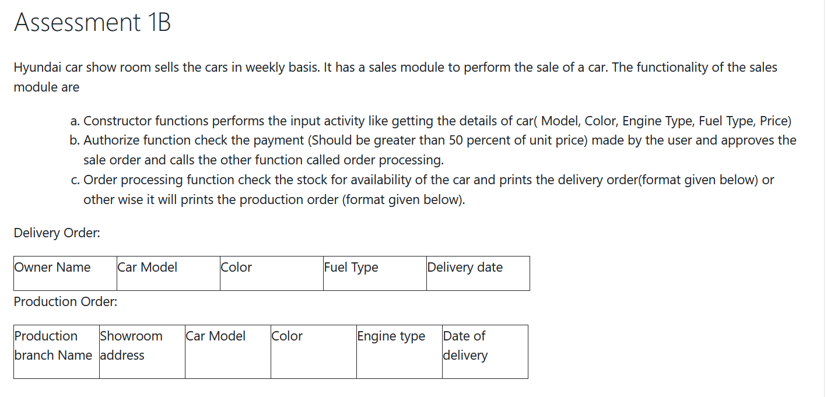  


**Data-base creation using Python**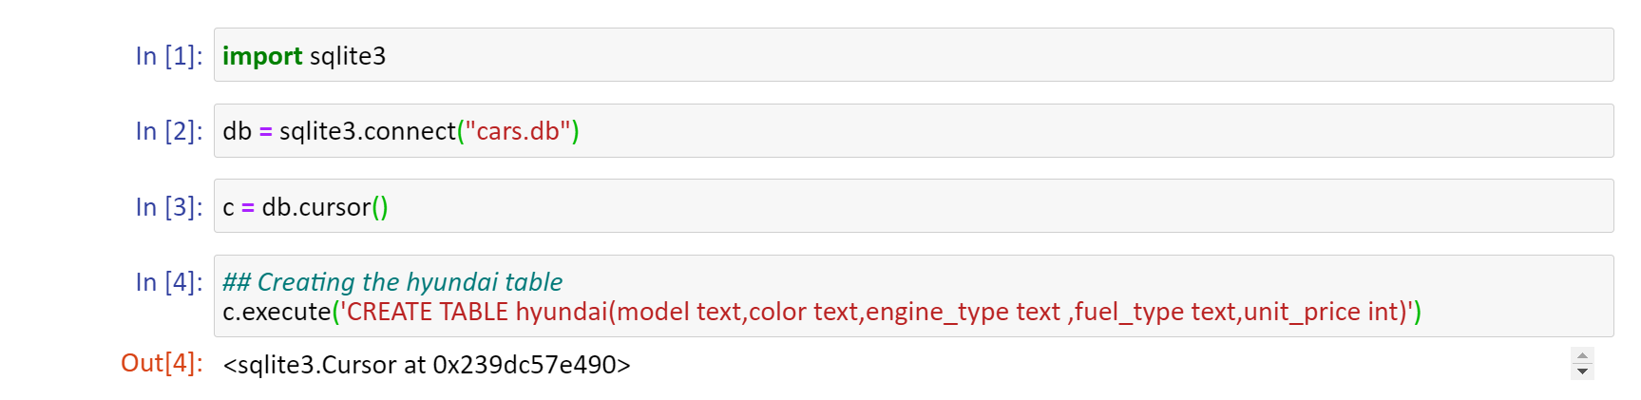  
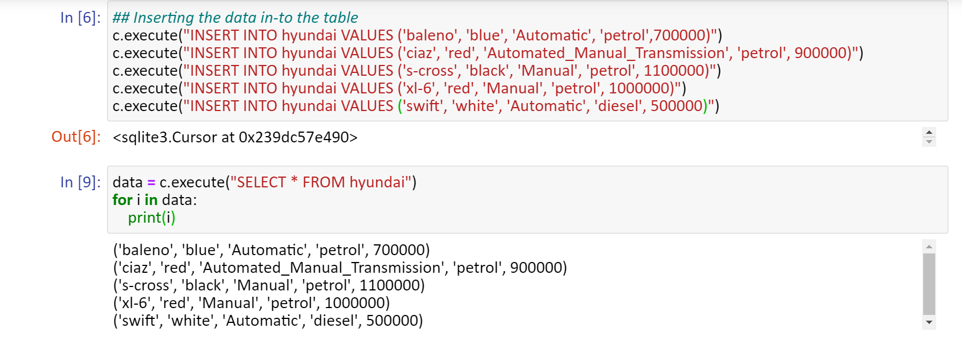

These data-base can be created using JAVA, so I created the data-base and inserted values using JDBC.

**Hyundai class**

**Structure of the Hyundai class**

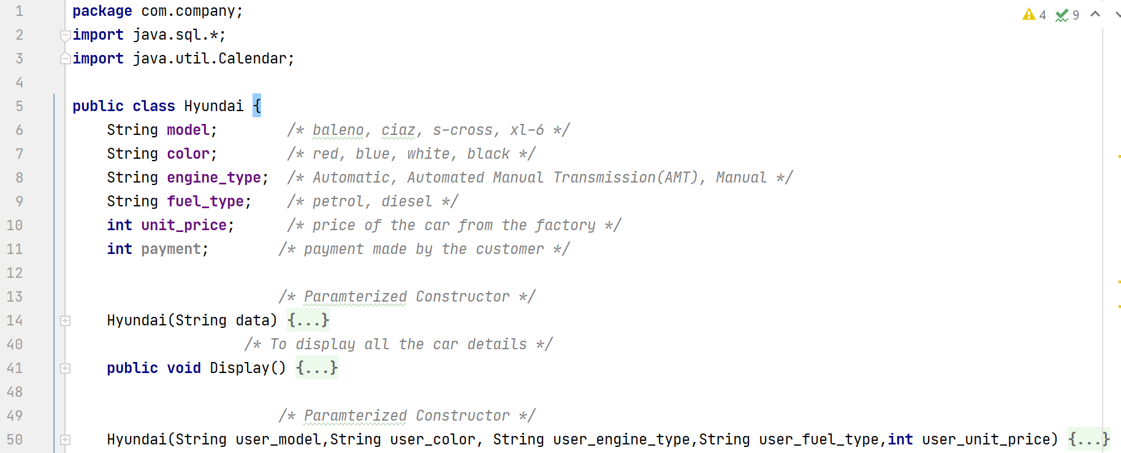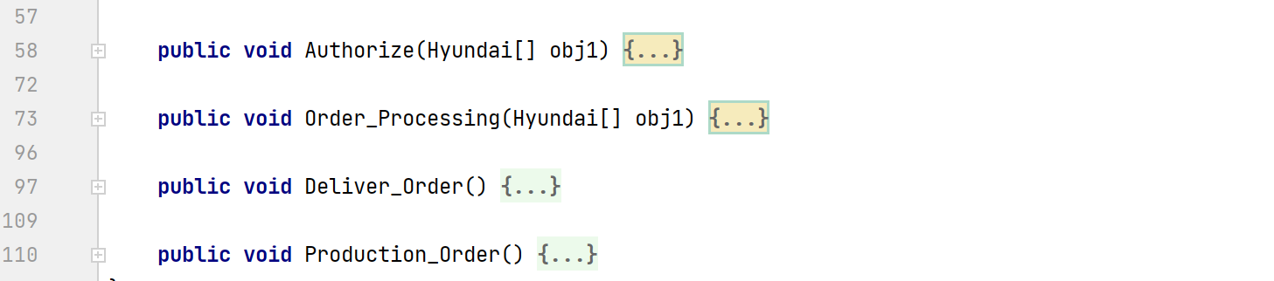

**Hyundai class**

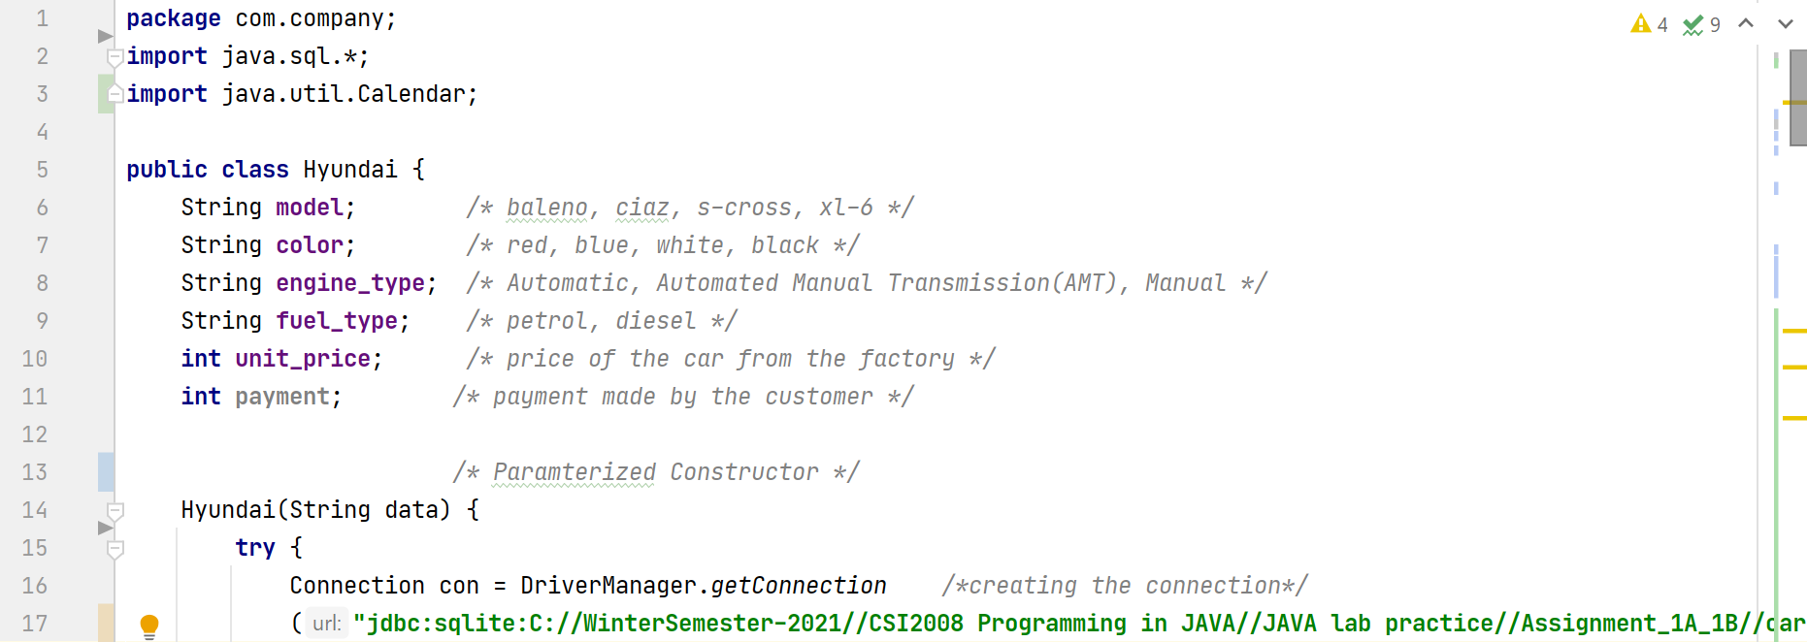  
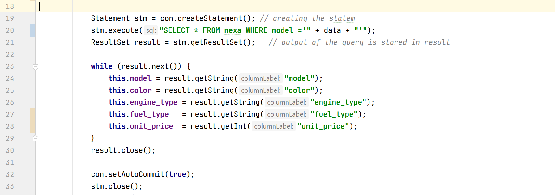  
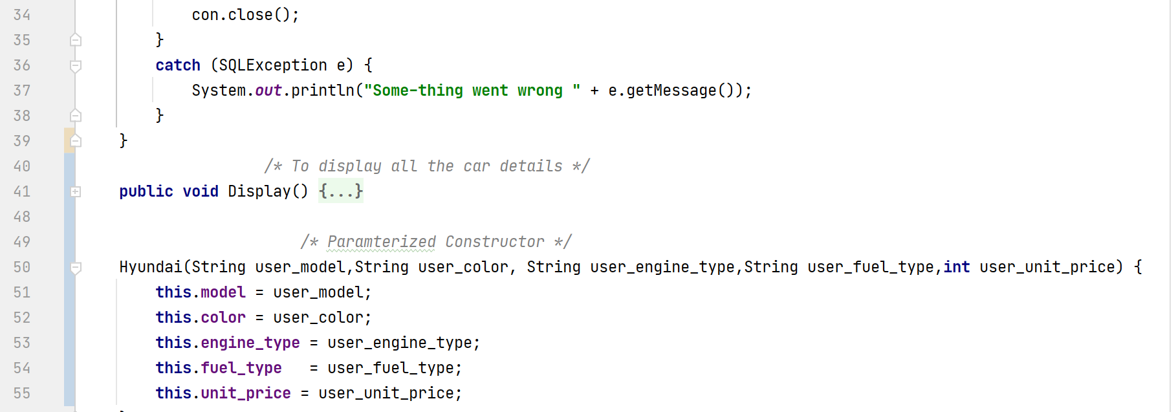

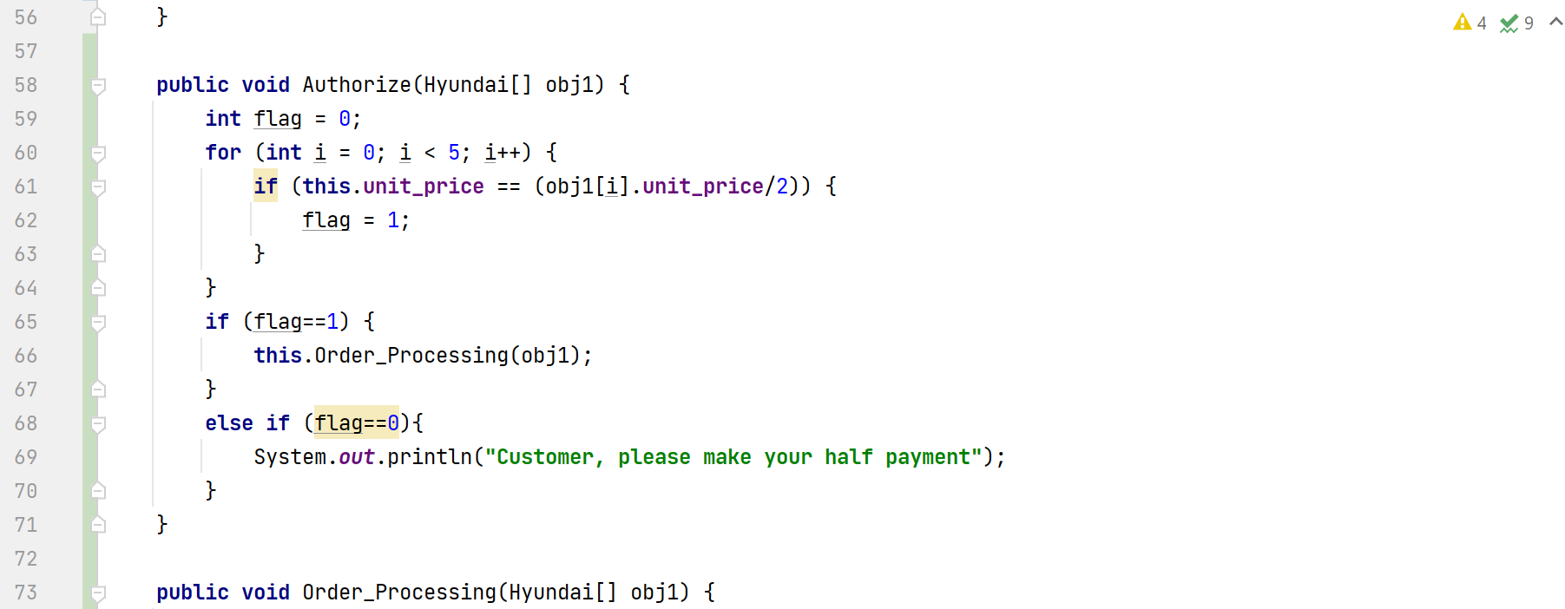  
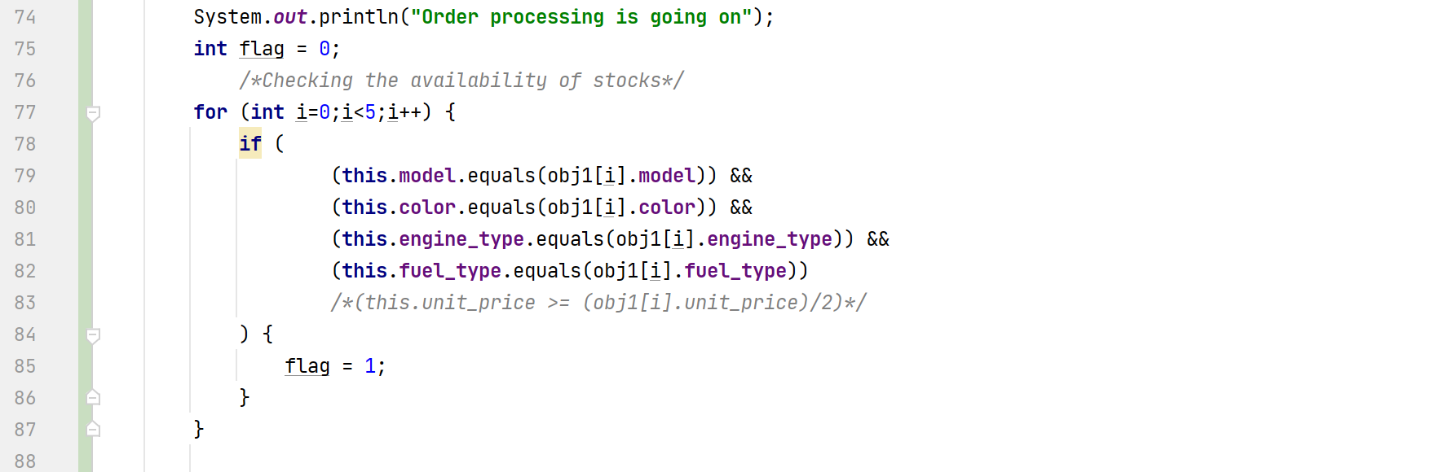  
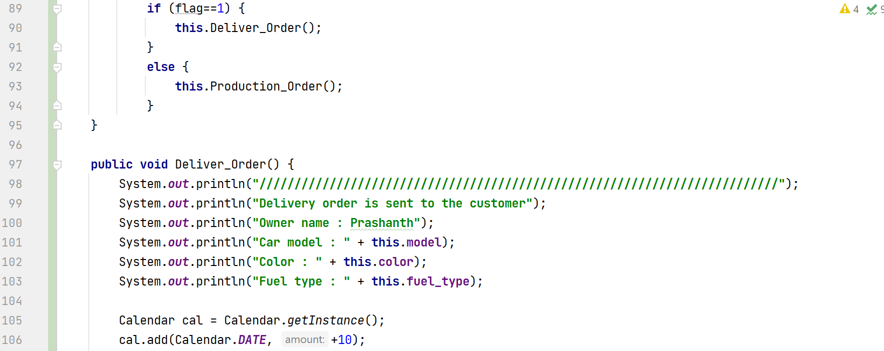  
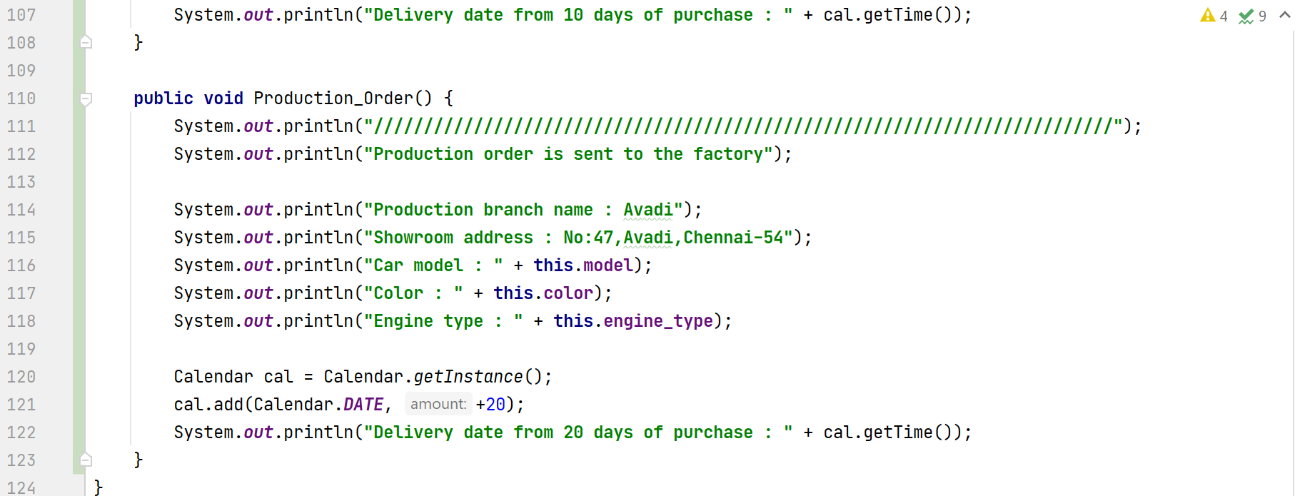

**Main function**

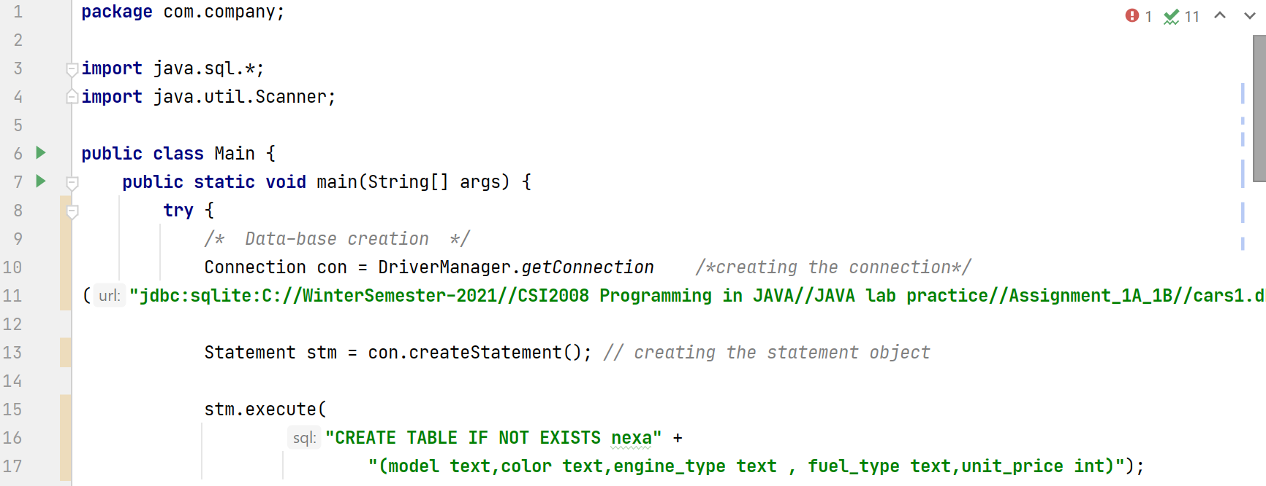  
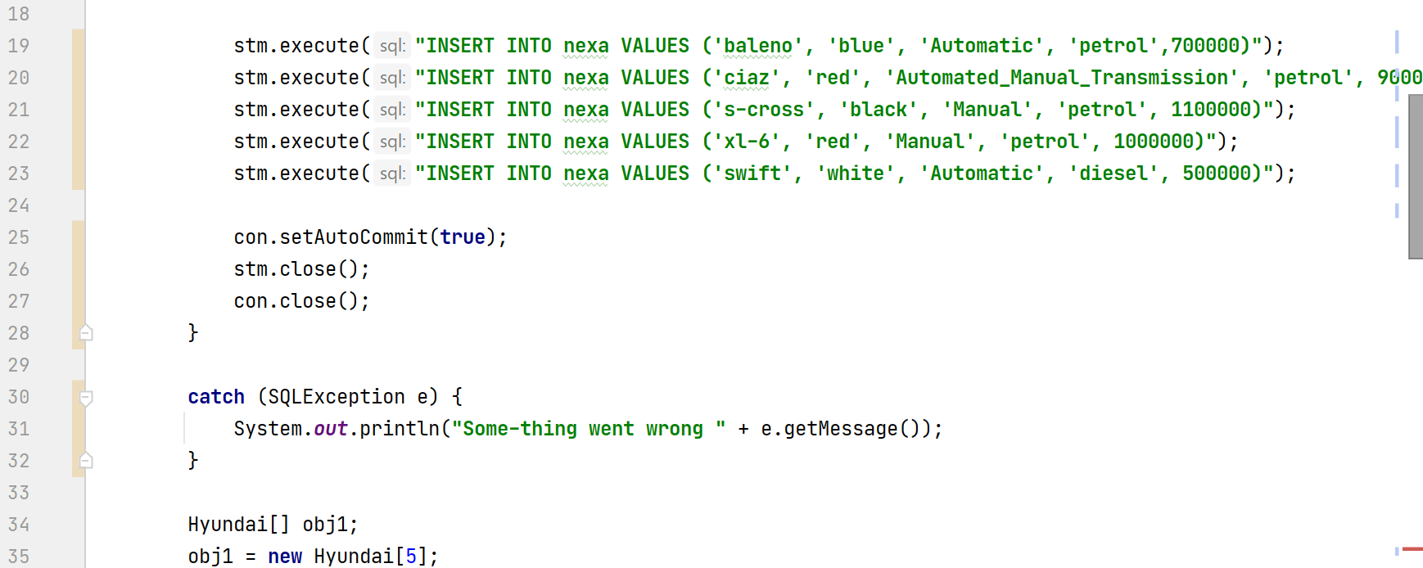

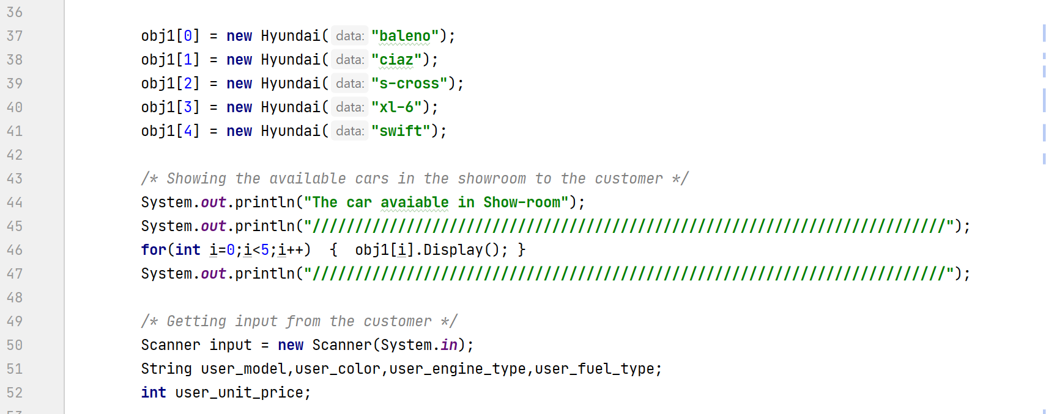

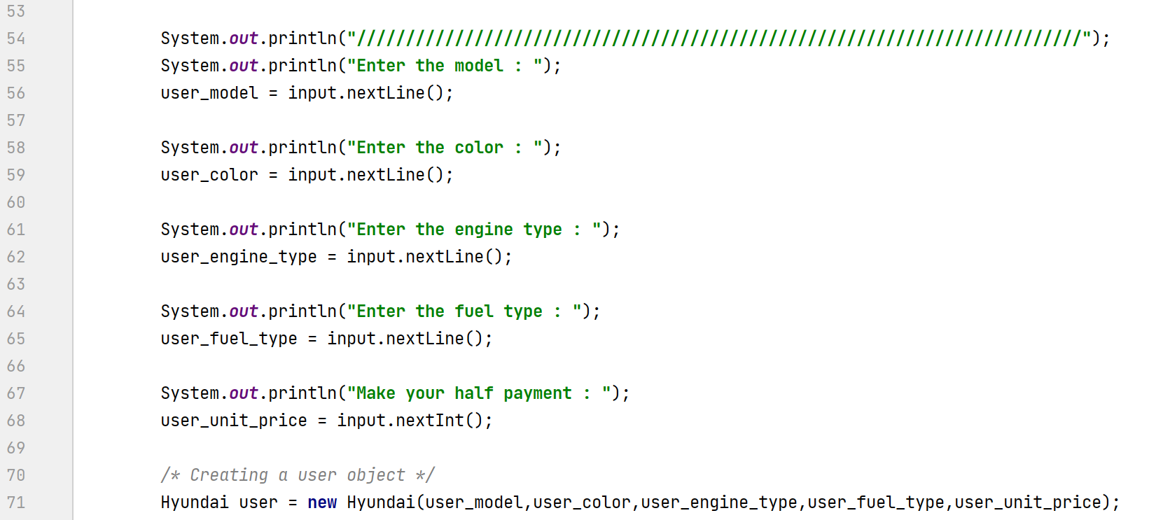  


**Data-base**

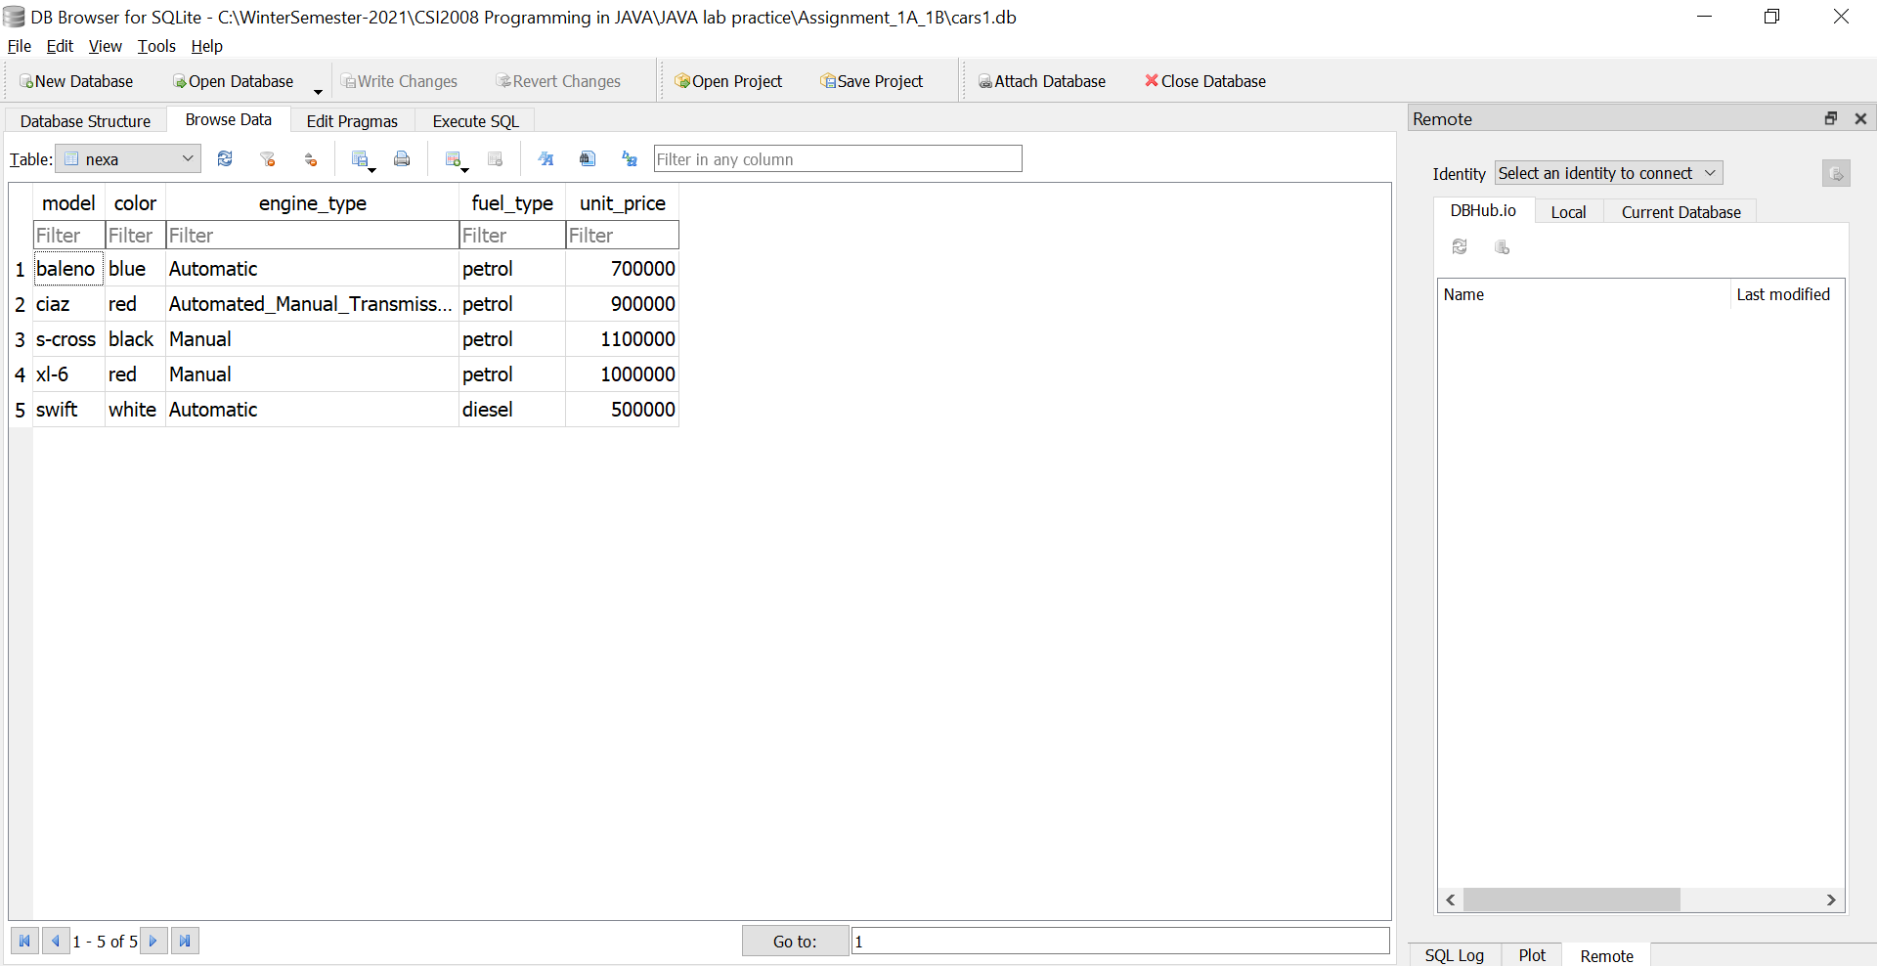

**Output: (User-choice available in Stocks)**  
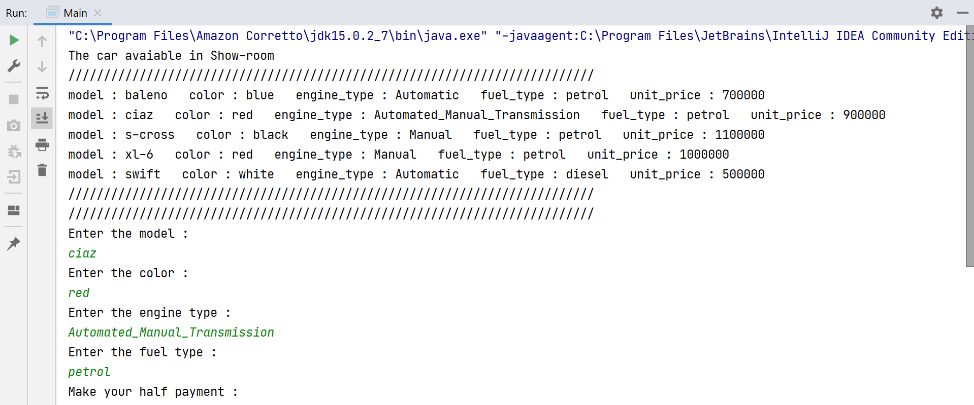  
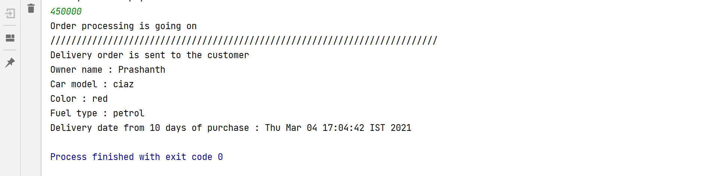

**Output: (User-choice not available in Stocks)**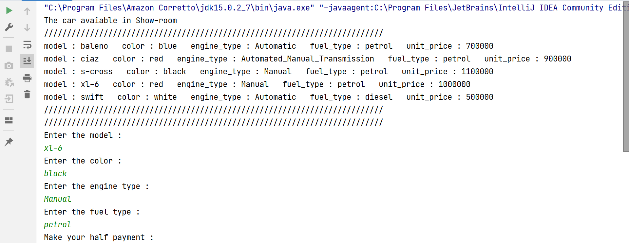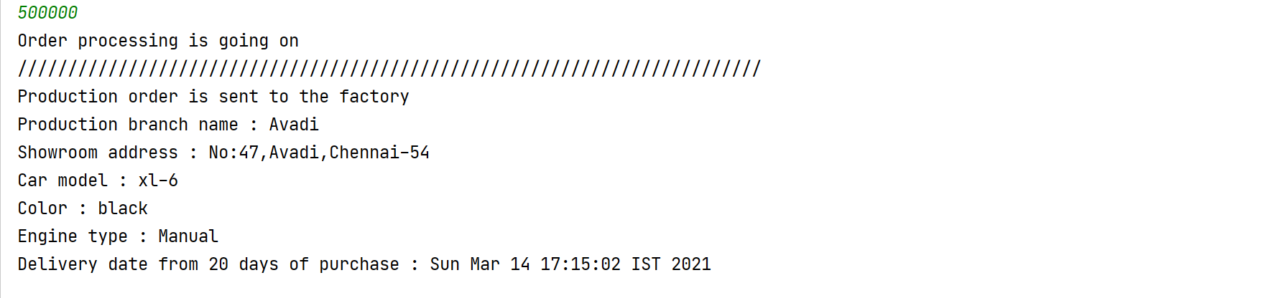

**Hyundai-Class**

**package** com.company;  
**import** java.sql.*;  
**import** java.util.Calendar;  
  
**public class** Hyundai {  
 String **model**; */* baleno, ciaz, s-cross, xl-6 */* String **color**; */* red, blue, white, black */* String **engine_type**; */* Automatic, Automated Manual Transmission(AMT), Manual */* String **fuel_type**; */* petrol, diesel */* **int unit_price**; */* price of the car from the factory */* **int payment**; */* payment made by the customer */  
  
 /* Paramterized Constructor */* Hyundai(String data) {  
 **try** {  
 Connection con = DriverManager.*getConnection /*creating the connection*/* (**"jdbc:sqlite:C://WinterSemester-2021//CSI2008 Programming in JAVA//JAVA lab practice//Assignment_1A_1B//cars1.db"**);  
  
 Statement stm = con.createStatement(); *// creating the statem* stm.execute(**"SELECT * FROM nexa WHERE model ='"** + data + **"'"**);  
 ResultSet result = stm.getResultSet(); *// output of the query is stored in result* **while** (result.next()) {  
 **this**.**model** = result.getString(**"model"**);  
 **this**.**color** = result.getString(**"color"**);  
 **this**.**engine_type** = result.getString(**"engine_type"**);  
 **this**.**fuel_type** = result.getString(**"fuel_type"**);  
 **this**.**unit_price** = result.getInt(**"unit_price"**);  
 }  
 result.close();  
  
 con.setAutoCommit(**true**);  
 stm.close();  
 con.close();  
 }  
 **catch** (SQLException e) {  
 System.***out***.println(**"Some-thing went wrong "** + e.getMessage());  
 }  
 }  
 */* To display all the car details */* **public void** Display() {  
 System.***out***.println(**"model : "** + **this**.**model** + **" "** +  
 **"color : "** + **this**.**color** + **" "** +  
 **"engine_type : "** + **this**.**engine_type** + **" "** +  
 **"fuel_type : "** + **this**.**fuel_type** + **" "** +  
 **"unit_price : "** + **this**.**unit_price**);  
 }  
  
 */* Paramterized Constructor */* Hyundai(String user_model,String user_color, String user_engine_type,String user_fuel_type,**int** user_unit_price) {  
 **this**.**model** = user_model;  
 **this**.**color** = user_color;  
 **this**.**engine_type** = user_engine_type;  
 **this**.**fuel_type** = user_fuel_type;  
 **this**.**unit_price** = user_unit_price;  
 }  
  
 **public void** Authorize(Hyundai[] obj1) {  
 **int** flag = 0;  
 **for** (**int** i = 0; i < 5; i++) {  
 **if** (**this**.**unit_price** == (obj1[i].**unit_price**/2)) {  
 flag = 1;  
 }  
 }  
 **if** (flag==1) {  
 **this**.Order_Processing(obj1);  
 }  
 **else if** (flag==0){  
 System.***out***.println(**"Customer, please make your half payment"**);  
 }  
 }  
  
 **public void** Order_Processing(Hyundai[] obj1) {  
 System.***out***.println(**"Order processing is going on"**);  
 **int** flag = 0;  
 */*Checking the availability of stocks*/* **for** (**int** i=0;i<5;i++) {  
 **if** (  
 (**this**.**model**.equals(obj1[i].**model**)) &&  
 (**this**.**color**.equals(obj1[i].**color**)) &&  
 (**this**.**engine_type**.equals(obj1[i].**engine_type**)) &&  
 (**this**.**fuel_type**.equals(obj1[i].**fuel_type**))  
 */*(this.unit_price >= (obj1[i].unit_price)/2)*/* ) {  
 flag = 1;  
 }  
 }  
  
 **if** (flag==1) {  
 **this**.Deliver_Order();  
 }  
 **else** {  
 **this**.Production_Order();  
 }  
 }  
  
 **public void** Deliver_Order() {  
 System.***out***.println(**"//////////////////////////////////////////////////////////////////////////"**);  
 System.***out***.println(**"Delivery order is sent to the customer"**);  
 System.***out***.println(**"Owner name : Prashanth"**);  
 System.***out***.println(**"Car model : "** + **this**.**model**);  
 System.***out***.println(**"Color : "** + **this**.**color**);  
 System.***out***.println(**"Fuel type : "** + **this**.**fuel_type**);  
  
 Calendar cal = Calendar.*getInstance*();  
 cal.add(Calendar.***DATE***, +10);  
 System.***out***.println(**"Delivery date from 10 days of purchase : "** + cal.getTime());  
 }  
  
 **public void** Production_Order() {  
 System.***out***.println(**"//////////////////////////////////////////////////////////////////////////"**);  
 System.***out***.println(**"Production order is sent to the factory"**);  
  
 System.***out***.println(**"Production branch name : Avadi"**);  
 System.***out***.println(**"Showroom address : No:47,Avadi,Chennai-54"**);  
 System.***out***.println(**"Car model : "** + **this**.**model**);  
 System.***out***.println(**"Color : "** + **this**.**color**);  
 System.***out***.println(**"Engine type : "** + **this**.**engine_type**);  
  
 Calendar cal = Calendar.*getInstance*();  
 cal.add(Calendar.***DATE***, +20);  
 System.***out***.println(**"Delivery date from 20 days of purchase : "** + cal.getTime());  
 }  
}

**Main method**

**package** com.company;  
  
**import** java.sql.*;  
**import** java.util.Scanner;  
  
**public class** Main {  
 **public static void** main(String[] args) {  
 **try** {  
 */* Data-base creation */* Connection con = DriverManager.*getConnection /*creating the connection*/* (**"jdbc:sqlite:C://WinterSemester-2021//CSI2008 Programming in JAVA//JAVA lab practice//Assignment_1A_1B//cars1.db"**);  
  
 Statement stm = con.createStatement(); *// creating the statement object* stm.execute(  
 **"CREATE TABLE IF NOT EXISTS nexa"** +  
 **"(model text,color text,engine_type text , fuel_type text,unit_price int)"**);  
  
 stm.execute(**"INSERT INTO nexa VALUES ('baleno', 'blue', 'Automatic', 'petrol',700000)"**);  
 stm.execute(**"INSERT INTO nexa VALUES ('ciaz', 'red', 'Automated_Manual_Transmission', 'petrol', 900000)"**);  
 stm.execute(**"INSERT INTO nexa VALUES ('s-cross', 'black', 'Manual', 'petrol', 1100000)"**);  
 stm.execute(**"INSERT INTO nexa VALUES ('xl-6', 'red', 'Manual', 'petrol', 1000000)"**);  
 stm.execute(**"INSERT INTO nexa VALUES ('swift', 'white', 'Automatic', 'diesel', 500000)"**);  
  
 con.setAutoCommit(**true**);  
 stm.close();  
 con.close();  
 }  
  
 **catch** (SQLException e) {  
 System.***out***.println(**"Some-thing went wrong "** + e.getMessage());  
 }  
  
 Hyundai[] obj1;  
 obj1 = **new** Hyundai[5];  
  
 obj1[0] = **new** Hyundai(**"baleno"**);  
 obj1[1] = **new** Hyundai(**"ciaz"**);  
 obj1[2] = **new** Hyundai(**"s-cross"**);  
 obj1[3] = **new** Hyundai(**"xl-6"**);  
 obj1[4] = **new** Hyundai(**"swift"**);  
  
 */* Showing the available cars in the showroom to the customer */* System.***out***.println(**"The car avaiable in Show-room"**);  
 System.***out***.println(**"//////////////////////////////////////////////////////////////////////////"**);  
 **for**(**int** i=0;i<5;i++) { obj1[i].Display(); }  
 System.***out***.println(**"//////////////////////////////////////////////////////////////////////////"**);  
  
 */* Getting input from the customer */* Scanner input = **new** Scanner(System.***in***);  
 String user_model,user_color,user_engine_type,user_fuel_type;  
 **int** user_unit_price;  
  
 System.***out***.println(**"//////////////////////////////////////////////////////////////////////////"**);  
 System.***out***.println(**"Enter the model : "**);  
 user_model = input.nextLine();  
  
 System.***out***.println(**"Enter the color : "**);  
 user_color = input.nextLine();  
  
 System.***out***.println(**"Enter the engine type : "**);  
 user_engine_type = input.nextLine();  
  
 System.***out***.println(**"Enter the fuel type : "**);  
 user_fuel_type = input.nextLine();  
  
 System.***out***.println(**"Make your half payment : "**);  
 user_unit_price = input.nextInt();  
  
 */* Creating a user object */* Hyundai user = **new** Hyundai(user_model,user_color,user_engine_type,user_fuel_type,user_unit_price);  
 user.Authorize(obj1);}

Github **:** [**https://github.com/PrashanthSingaravelan/WinterSemester-2021/tree/main/CSI2008%20Programming%20in%20JAVA/JAVA%20lab%20practice/Assignment_1A_1B**](https://github.com/PrashanthSingaravelan/WinterSemester-2021/tree/main/CSI2008%20Programming%20in%20JAVA/JAVA%20lab%20practice/Assignment_1A_1B)